الجمهورية اليمنية
جامعة إب

كلية الحاسبات
علوم الحاسوب وتقنية المعلومات
المستوى الرابع
مقرر: معالجة صور رقمية - عملي
DIP-Lab-6
اسم الطالب: رؤوف صادق عبده محمد قايد العقاب.
المجموعة:(1A).
بإشراف من مدرس المقرر: م/ مالك المصنف

1448

2026/2027

: 1. الفلاتر وتقنيات معالجة الصور المستخدمة:
- : Grayscale تحويل الصورة إلى تدرج رمادي.
- : Median Filter إزالة الضوضاء، خصوصًا Salt & Pepper.
- : Gaussian Filter تنعيم الصورة وتقليل الضوضاء.
- : CLAHE تحسين التباين وإبراز الأرقام والرموز.
- : Otsu Thresholding تحويل الصورة إلى Binary تلقائيًا.
- : Adaptive Thresholding معالجة الصور ذات الإضاءة غير المتجانسة عند الحاجة.
- Morphological Opening: إزالة النقاط والضوضاء الصغيرة.
- : Morphological Closing سد الفجوات داخل الأرقام والرموز.
- : Canny Edge Detection استخراج حواف الأرقام والرموز.
- : Connected Components / Contours تحديد المكونات وفصل الأرقام والرموز.

2. صور الأرقام التي تم استخدامها:
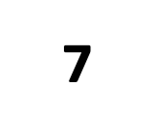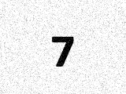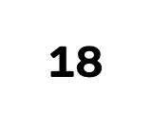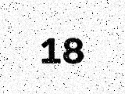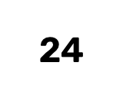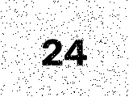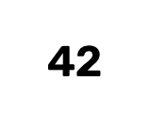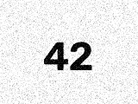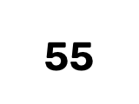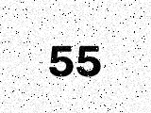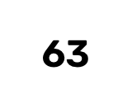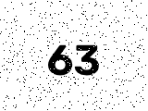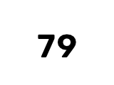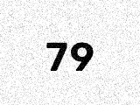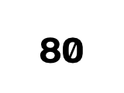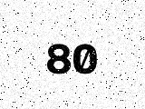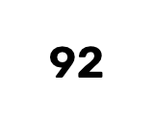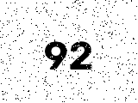

3. صور العمليات:
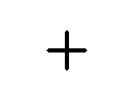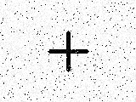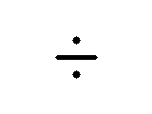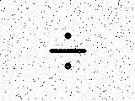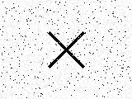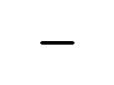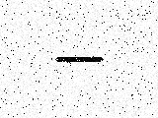

4. خوارزمية عمل البرنامج بالضبط
- إدخال 3 صور:
  - صورة الرقم الأول.
  - صورة العملية الحسابية.
  - صورة الرقم الثاني.
- تحويل كل صورة إلى Grayscale .
- إزالة الضوضاء :
  - يبدأ البرنامج بالـ Median Filter .
  - وإذا كانت النتيجة غير مناسبة يستخدم Gaussian ضمن Pipeline بديل.
- تحسين الصورة عند الحاجة :
  - استخدام CLAHE لتحسين التباين في الصور الصعبة.
- تحويل الصورة إلى: Binary
  - استخدام Otsu Thresholding .
  - استخدام Adaptive Thresholding كبديل عند الحاجة.
- تطبيق العمليات Morphology:
  - Opening لإزالة الأجزاء الصغيرة غير المرغوبة.
  - Closing لسد الفجوات داخل الأرقام والرموز.
- استخراج الحواف :
  - تطبيق Canny Edge Detection للحصول على Edge Map .
- اكتشاف المكونات :
  - استخدام Contours / Connected Components لاكتشاف الأجزاء الموجودة في الصورة.
  - إزالة المكونات الصغيرة الناتجة عن الضوضاء.
- تجزئة الرقم :
  - إذا كان الرقم مكونًا من أكثر من خانة، يتم تحديد Bounding Box لكل خانة.
  - ترتيب الخانات من اليسار إلى اليمين.
  - قص كل خانة منفردة.
- توحيد حجم الخانات :
  - تحويل كل رقم إلى حجم قياسي.
  - الحفاظ على Aspect Ratio .
  - توسيط الرقم داخل الصورة.
- التعرف على الأرقام :
  - مقارنة كل خانة مع Templates للأرقام من 0 إلى 9 باستخدام Template Matching .
  - اختيار الرقم صاحب أعلى درجة تطابق.
  - تجميع الخانات لتكوين الرقم الكامل، مثل:
9 + 2 → 92
- التعرف على العملية الحسابية :
  - تحليل شكل المكونات.
  - استخدام Template Matching للتأكيد.
  - التعرف على:
+ , − , × , ÷
  - بالنسبة لـ ÷ يتم التعامل مع مكوناته الثلاثة: نقطة علوية + خط + نقطة سفلية.
- Fallback عند ضعف النتيجة :
  - إذا كانت درجة الثقة منخفضة، يعيد البرنامج معالجة الصورة باستخدام Pipeline بديل.
  - يتم اختيار أفضل نتيجة.
- بناء التعبير الحسابي:
  - بعد التعرف على الصور الثلاث:
الرقم الأول + العملية + الرقم الثاني
- التحقق من التعبير :
  - التأكد من أن الرقمين والعملية تم التعرف عليهم بشكل صحيح.
  - منع القسمة على صفر.
- تنفيذ العملية
  - استخدام دوال حسابية صريحة مثل الجمع والطرح والضرب والقسمة.
  - لا يتم استخدام eval() .
- عرض النتيجة في واجهة Tkinter :
  - التعبير المتعرف عليه.
  - العملية الحسابية.
  - النتيجة النهائية.

5. الكود البرمجي لوحدات النظام (Source Code Screenshots)

أولاً: كود المعالجة المسبقة وخطوط الأنابيب (preprocessing.py):

import cv2
import numpy as np

def to_grayscale(image: np.ndarray) -> np.ndarray:
"""Converts image to grayscale if not already."""
if len(image.shape) == 3 and image.shape[2] == 3:
return cv2.cvtColor(image, cv2.COLOR_BGR2GRAY)
elif len(image.shape) == 3 and image.shape[2] == 4:
return cv2.cvtColor(image, cv2.COLOR_BGRA2GRAY)
return image.copy()

def apply_gaussian_blur(gray: np.ndarray, ksize=(3, 3), sigma=0) -> np.ndarray:
"""Applies Gaussian smoothing to suppress Gaussian noise."""
if ksize[0] % 2 == 0 or ksize[1] % 2 == 0:
ksize = (ksize[0] | 1, ksize[1] | 1)
return cv2.GaussianBlur(gray, ksize, sigma)

def apply_median_filter(gray: np.ndarray, ksize=3) -> np.ndarray:
"""Applies Median filtering - highly effective against Salt & Pepper noise."""
if ksize % 2 == 0:
ksize += 1
return cv2.medianBlur(gray, ksize)

def apply_clahe(gray: np.ndarray, clip_limit=2.0, tile_grid_size=(8, 8)) -> np.ndarray:
"""Contrast Limited Adaptive Histogram Equalization for contrast enhancement."""
clahe = cv2.createCLAHE(clipLimit=clip_limit, tileGridSize=tile_grid_size)
return clahe.apply(gray)

def apply_threshold(gray: np.ndarray, method="otsu", invert=True) -> np.ndarray:
"""
Thresholds the image to return a binary image where foreground (digits/operator) is 255 (white)
and background is 0 (black).
"""
thresh_type = cv2.THRESH_BINARY_INV if invert else cv2.THRESH_BINARY

if method == "otsu":
_, binary = cv2.threshold(gray, 0, 255, thresh_type + cv2.THRESH_OTSU)
return binary
elif method == "adaptive":
binary = cv2.adaptiveThreshold(
gray, 255, cv2.ADAPTIVE_THRESH_GAUSSIAN_C, thresh_type, 15, 4
)
return binary
else: # simple fixed threshold
_, binary = cv2.threshold(gray, 127, 255, thresh_type)
return binary

def apply_morphology(binary: np.ndarray, op="open", ksize=3) -> np.ndarray:
"""
Applies morphological operations:
- 'open': erosion followed by dilation (removes small noise specks).
- 'close': dilation followed by erosion (bridges small gaps in strokes).
"""
kernel = cv2.getStructuringElement(cv2.MORPH_RECT, (ksize, ksize))
if op == "open":
return cv2.morphologyEx(binary, cv2.MORPH_OPEN, kernel)
elif op == "close":
return cv2.morphologyEx(binary, cv2.MORPH_CLOSE, kernel)
return binary

def run_pipeline(image: np.ndarray, pipeline_name="pipeline_1") -> dict:
"""
Executes a specific preprocessing pipeline and returns intermediate images at each step
for visualization and subsequent edge detection/segmentation.
Output binary has foreground = 255, background = 0.
"""
gray = to_grayscale(image)

if pipeline_name == "pipeline_1":
# Pipeline 1: Median filter + Otsu + Morph Close
# Ideal for Salt & Pepper noise and standard text
denoised = apply_median_filter(gray, ksize=3)
binary = apply_threshold(denoised, method="otsu", invert=True)
morph = apply_morphology(binary, op="close", ksize=3)

elif pipeline_name == "pipeline_2":
# Pipeline 2: Gaussian Blur + Otsu + Morph Open + Close
# Ideal for Gaussian noise and slight stroke irregularities
denoised = apply_gaussian_blur(gray, ksize=(3, 3), sigma=0.8)
binary = apply_threshold(denoised, method="otsu", invert=True)
opened = apply_morphology(binary, op="open", ksize=3)
morph = apply_morphology(opened, op="close", ksize=3)

elif pipeline_name == "pipeline_3":
# Pipeline 3: Median filter + CLAHE + Otsu + Morph Close
# Ideal for combined noise or lower contrast images
denoised = apply_median_filter(gray, ksize=3)
enhanced = apply_clahe(denoised, clip_limit=2.0)
binary = apply_threshold(enhanced, method="otsu", invert=True)
morph = apply_morphology(binary, op="close", ksize=3)

else:
# Default fallback
denoised = apply_median_filter(gray, ksize=3)
binary = apply_threshold(denoised, method="otsu", invert=True)
morph = binary

return {
"pipeline_name": pipeline_name,
"original": image,
"gray": gray,
"denoised": denoised,
"binary": binary,
"morph": morph
}

ثانياً: كود كشف الحواف والمكونات المتصلة (edge_detection.py):
"""
edge_detection.py - Edge detection and contour/component extraction module.
Applies Canny edge detection with dynamic thresholds, extracts clean contours,
and provides connected components analysis (vital for multi-element operators like '÷').
"""

import cv2
import numpy as np

def apply_canny(image: np.ndarray, low_threshold=None, high_threshold=None) -> np.ndarray:
"""
Applies Canny edge detector with automatic thresholding if not provided.
Accepts grayscale or smoothed image.
"""
if len(image.shape) == 3:
image = cv2.cvtColor(image, cv2.COLOR_BGR2GRAY)

if low_threshold is None or high_threshold is None:
# Dynamic Otsu-based thresholding
otsu_val, _ = cv2.threshold(image, 0, 255, cv2.THRESH_BINARY + cv2.THRESH_OTSU)
high_threshold = otsu_val
low_threshold = otsu_val * 0.5

edges = cv2.Canny(image, int(low_threshold), int(high_threshold))
return edges

def find_clean_contours(binary_mask: np.ndarray, min_area=25) -> list[dict]:
"""
Finds external contours and filters out noise contours with area < min_area.
Returns list of contour info dicts with contour, bounding box (x, y, w, h), and area.
"""
contours, hierarchy = cv2.findContours(
binary_mask, cv2.RETR_EXTERNAL, cv2.CHAIN_APPROX_SIMPLE
)

clean = []
for c in contours:
area = cv2.contourArea(c)
if area >= min_area:
x, y, w, h = cv2.boundingRect(c)
clean.append({
"contour": c,
"bbox": (x, y, w, h),
"area": area,
"aspect_ratio": float(w) / max(1, h)
})

return clean

def find_connected_components(binary_mask: np.ndarray, min_area=20) -> list[dict]:
"""
Extracts connected components from a binary image (where foreground is 255).
Crucial for distinguishing operations like '÷' (which has 3 distinct components: dot, bar, dot).
Returns list of component dicts filtered by min_area.
"""
num_labels, labels, stats, centroids = cv2.connectedComponentsWithStats(
binary_mask, connectivity=8
)

components = []
# label 0 is background, so iterate from 1 to num_labels - 1
for label in range(1, num_labels):
area = stats[label, cv2.CC_STAT_AREA]
if area >= min_area:
x = stats[label, cv2.CC_STAT_LEFT]
y = stats[label, cv2.CC_STAT_TOP]
w = stats[label, cv2.CC_STAT_WIDTH]
h = stats[label, cv2.CC_STAT_HEIGHT]
cx, cy = centroids[label]

# Mask for this specific component
comp_mask = np.uint8(labels == label) * 255
crop = comp_mask[y:y+h, x:x+w]

components.append({
"label": label,
"bbox": (x, y, w, h),
"area": area,
"centroid": (float(cx), float(cy)),
"aspect_ratio": float(w) / max(1, h),
"mask": comp_mask,
"crop": crop
})

return components

def clean_edges_with_components(edges: np.ndarray, binary_mask: np.ndarray, min_area=25) -> np.ndarray:
"""
Cleans edge image by suppressing edges that do not belong to significant connected components.
Eliminates stray noise edges caused by salt & pepper noise.
"""
comps = find_connected_components(binary_mask, min_area=min_area)
valid_mask = np.zeros_like(binary_mask)
for comp in comps:
valid_mask = cv2.bitwise_or(valid_mask, comp["mask"])

# Dilate valid mask slightly to cover edge boundaries
dilated_mask = cv2.dilate(valid_mask, cv2.getStructuringElement(cv2.MORPH_RECT, (3, 3)))
clean_edges = cv2.bitwise_and(edges, dilated_mask)
return clean_edges

ثالثاً: كود التجزئة وتوحيد المقاس المعياري (segmentation.py):
"""
segmentation.py - Segmentation module for extracting individual digits.
Sorts candidate bounding boxes Left -> Right, isolates each digit ROI,
and applies standardized normalization matching the template generator.
"""

import cv2
import numpy as np

DEFAULT_TARGET_SIZE = (32, 32)

def normalize_roi(roi_binary: np.ndarray, target_size=DEFAULT_TARGET_SIZE) -> np.ndarray:
"""
Standardizes a segmented digit binary mask (255=foreground, 0=background)
into target_size with aspect-ratio preserved centering.
Guarantees 100% consistency with generate_templates.py.
"""
th, tw = target_size
pad_box = np.zeros((th, tw), dtype=np.uint8)

# Locate exact non-zero boundaries
coords = cv2.findNonZero(roi_binary)
if coords is None:
return pad_box

x, y, w, h = cv2.boundingRect(coords)
if w <= 0 or h <= 0:
return pad_box

crop = roi_binary[y:y+h, x:x+w]

# Scale to fit inside (target - 4) with preserved aspect ratio
max_dim = max(w, h)
margin = 4
scale = (min(th, tw) - margin) / float(max_dim)
new_w = max(1, int(w * scale))
new_h = max(1, int(h * scale))

resized = cv2.resize(crop, (new_w, new_h), interpolation=cv2.INTER_AREA)
# Ensure sharp binary
resized = cv2.threshold(resized, 100, 255, cv2.THRESH_BINARY)[1]

start_x = (tw - new_w) // 2
start_y = (th - new_h) // 2
pad_box[start_y:start_y+new_h, start_x:start_x+new_w] = resized
return pad_box

def segment_digits(binary_mask: np.ndarray, min_area=35, min_height=12) -> list[dict]:
"""
Segments candidate digit regions from a preprocessed binary mask.
Filters noise, sorts bounding boxes from Left to Right,
and returns a list of normalized digit items.
"""
# Use connected components to cleanly separate digits
num_labels, labels, stats, centroids = cv2.connectedComponentsWithStats(
binary_mask, connectivity=8
)

candidates = []
for label in range(1, num_labels):
area = stats[label, cv2.CC_STAT_AREA]
w = stats[label, cv2.CC_STAT_WIDTH]
h = stats[label, cv2.CC_STAT_HEIGHT]
x = stats[label, cv2.CC_STAT_LEFT]
y = stats[label, cv2.CC_STAT_TOP]

# Filter out tiny noise specks or border artifacts
if area < min_area or h < min_height or w < 3:
continue

comp_mask = np.uint8(labels == label) * 255
crop = comp_mask[y:y+h, x:x+w]

norm_roi = normalize_roi(crop, DEFAULT_TARGET_SIZE)

candidates.append({
"label": label,
"bbox": (x, y, w, h),
"area": area,
"aspect_ratio": float(w) / max(1, h),
"raw_crop": crop,
"normalized_roi": norm_roi
})

# Crucial step: Sort from Left to Right by x-coordinate
candidates.sort(key=lambda item: item["bbox"][0])

return candidates

رابعاً: كود التعرف المستقل على الأرقام (digit_recognizer.py):
"""
digit_recognizer.py - Digit recognition module using normalized template matching.
Independent from operator recognition. Evaluates digits against 0..9 templates
and computes a unified confidence metric.
"""

import os
import cv2
import numpy as np
from segmentation import segment_digits, normalize_roi

DEFAULT_CONFIDENCE_THRESHOLD = 0.70

class DigitRecognizer:
def __init__(self, templates_dir="templates/digits"):
self.templates_dir = templates_dir
self.templates = {}
self.load_templates()

def load_templates(self):
"""Loads all digit templates 0..9."""
for d in range(10):
path = os.path.join(self.templates_dir, f"{d}.png")
if os.path.exists(path):
tpl = cv2.imread(path, cv2.IMREAD_GRAYSCALE)
# Ensure binary
_, tpl_bin = cv2.threshold(tpl, 127, 255, cv2.THRESH_BINARY)
self.templates[str(d)] = tpl_bin
else:
raise FileNotFoundError(f"Template not found: {path}")

def score_match(self, roi_bin: np.ndarray, template_bin: np.ndarray) -> float:
"""
Computes a unified similarity score (0.0 to 1.0) combining:
1. Normalized Cross-Correlation (TM_CCOEFF_NORMED)
2. Binary Intersection-over-Union (IoU)
"""
# 1. TM_CCOEFF_NORMED
res = cv2.matchTemplate(roi_bin, template_bin, cv2.TM_CCOEFF_NORMED)
corr = float(res[0][0])
corr_score = max(0.0, corr)

# 2. IoU
intersection = np.sum((roi_bin > 0) & (template_bin > 0))
union = np.sum((roi_bin > 0) | (template_bin > 0))
iou_score = float(intersection) / max(1.0, float(union))

# Unified confidence
confidence = 0.6 * corr_score + 0.4 * iou_score
return round(float(confidence), 4)

def recognize_single_digit(self, norm_roi: np.ndarray) -> dict:
"""Matches a single normalized digit ROI against templates 0..9."""
best_char = None
best_conf = -1.0
scores = {}

for d_str, tpl in self.templates.items():
conf = self.score_match(norm_roi, tpl)
scores[d_str] = conf
if conf > best_conf:
best_conf = conf
best_char = d_str

return {
"char": best_char,
"confidence": best_conf,
"all_scores": scores
}

def recognize_image(self, binary_mask: np.ndarray, min_conf=DEFAULT_CONFIDENCE_THRESHOLD) -> dict:
"""
Takes a binary mask (e.g. from preprocessing pipeline),
segments digits from left to right, and recognizes each digit.
Assembles multi-digit numbers (e.g., 9 and 2 -> 92).
"""
segments = segment_digits(binary_mask)
if not segments:
return {
"success": False,
"value": None,
"string": "",
"confidence": 0.0,
"digits": [],
"error": "No digits segmented"
}

recognized_digits = []
confidences = []

for seg in segments:
rec = self.recognize_single_digit(seg["normalized_roi"])
recognized_digits.append({
"char": rec["char"],
"confidence": rec["confidence"],
"bbox": seg["bbox"]
})
confidences.append(rec["confidence"])

full_str = "".join([d["char"] for d in recognized_digits])

# Unified overall confidence: weighted average with minimum penalty
min_c = min(confidences)
avg_c = sum(confidences) / len(confidences)
overall_conf = round(0.7 * min_c + 0.3 * avg_c, 4)

success = (overall_conf >= min_conf) and (len(full_str) > 0)

try:
val = int(full_str)
except ValueError:
val = None
success = False

return {
"success": success,
"value": val,
"string": full_str,
"confidence": overall_conf,
"digits": recognized_digits,
"error": None if success else f"Confidence {overall_conf:.2f} below threshold {min_conf:.2f}"
}

خامساً: كود التعرف المستقل على العمليات (operator_recognizer.py):
"""
operator_recognizer.py - Operator recognition module (+, -, ×, ÷).
Completely separated from digit recognition.
Combines simple geometric/shape analysis (Connected Components, aspect ratio,
stroke distribution) with normalized template matching for robust confirmation.
"""

import os
import cv2
import numpy as np
from edge_detection import find_connected_components, apply_canny
from segmentation import normalize_roi, DEFAULT_TARGET_SIZE

DEFAULT_CONFIDENCE_THRESHOLD = 0.70

class OperatorRecognizer:
def __init__(self, templates_dir="templates/operators"):
self.templates_dir = templates_dir
self.templates = {}
self.load_templates()

def load_templates(self):
"""Loads operator templates: add (+), sub (-), mul (×), div (÷)."""
mapping = {
"+": "add.png",
"-": "sub.png",
"×": "mul.png",
"÷": "div.png"
}
for op, filename in mapping.items():
path = os.path.join(self.templates_dir, filename)
if os.path.exists(path):
tpl = cv2.imread(path, cv2.IMREAD_GRAYSCALE)
_, tpl_bin = cv2.threshold(tpl, 127, 255, cv2.THRESH_BINARY)
self.templates[op] = tpl_bin
else:
raise FileNotFoundError(f"Template operator not found: {path}")

def score_template(self, roi_bin: np.ndarray, template_bin: np.ndarray) -> float:
"""Unified template matching score (TM_CCOEFF_NORMED + IoU)."""
res = cv2.matchTemplate(roi_bin, template_bin, cv2.TM_CCOEFF_NORMED)
corr_score = max(0.0, float(res[0][0]))

intersection = np.sum((roi_bin > 0) & (template_bin > 0))
union = np.sum((roi_bin > 0) | (template_bin > 0))
iou_score = float(intersection) / max(1.0, float(union))

return 0.6 * corr_score + 0.4 * iou_score

def analyze_geometry(self, components: list[dict], binary_mask: np.ndarray) -> dict:
"""
Simple geometric shape analysis using Connected Components:
- 3 components aligned vertically (dot, bar, dot) -> '÷'
- 1 component with W/H > 2.0 -> '-'
- 1 component roughly square -> examine cross (+) vs diagonal (×)
"""
num_comps = len(components)

# 1. Division check: 3 vertically aligned components (or 2 if one dot merged/lost)
if num_comps == 3:
# Sort by y-coordinate (top to bottom)
sorted_by_y = sorted(components, key=lambda c: c["bbox"][1])
top_comp, mid_comp, bot_comp = sorted_by_y

# Middle component should be horizontal bar (aspect ratio > 1.5)
mid_ar = mid_comp["aspect_ratio"]
if mid_ar > 1.4:
return {"suggested": "÷", "confidence_bonus": 0.25, "reason": "3-component division (dot-bar-dot)"}
elif num_comps == 2:
# Sometimes 1 dot + 1 bar
sorted_by_y = sorted(components, key=lambda c: c["bbox"][1])
for comp in sorted_by_y:
if comp["aspect_ratio"] > 1.6:
return {"suggested": "÷", "confidence_bonus": 0.15, "reason": "2-component division"}

# If 1 primary component (or after taking the largest):
if num_comps >= 1:
largest = max(components, key=lambda c: c["area"])
ar = largest["aspect_ratio"]

# Horizontal line check: Minus '-'
if ar >= 2.0:
return {"suggested": "-", "confidence_bonus": 0.25, "reason": "High aspect-ratio horizontal stroke (-)"}

# Square-like bounding box: Check + vs ×
if 0.7 <= ar <= 1.4:
# Analyze central pixel distribution vs corners
norm = normalize_roi(largest["crop"], (32, 32))
h, w = norm.shape

# In '+', middle cross (row 15-17, col 15-17) is filled, but 4 corners are empty
# In '×', corners have diagonals
corner_sum = (
np.sum(norm[2:8, 2:8] > 0) +
np.sum(norm[2:8, 24:30] > 0) +
np.sum(norm[24:30, 2:8] > 0) +
np.sum(norm[24:30, 24:30] > 0)
)

# Cross arms at top-center, bottom-center, left-center, right-center
plus_arms_sum = (
np.sum(norm[2:8, 14:18] > 0) +
np.sum(norm[24:30, 14:18] > 0) +
np.sum(norm[14:18, 2:8] > 0) +
np.sum(norm[14:18, 24:30] > 0)
)

if plus_arms_sum > corner_sum * 1.5:
return {"suggested": "+", "confidence_bonus": 0.20, "reason": "Axis-aligned cross (+)"}
elif corner_sum > plus_arms_sum * 1.2:
return {"suggested": "×", "confidence_bonus": 0.20, "reason": "Diagonal strokes (×)"}

return {"suggested": None, "confidence_bonus": 0.0, "reason": "Generic shape"}

def recognize_image(self, binary_mask: np.ndarray, min_conf=DEFAULT_CONFIDENCE_THRESHOLD) -> dict:
"""
Recognizes operator from binary mask (+, -, ×, ÷).
Integrates Canny edge information, Connected Components, and Template Matching.
"""
# Extract connected components (ignoring tiny noise < 15px)
comps = find_connected_components(binary_mask, min_area=15)
if not comps:
return {
"success": False,
"symbol": None,
"confidence": 0.0,
"reason": "No components found",
"all_scores": {}
}

# Step 1: Geometric structural analysis
geom = self.analyze_geometry(comps, binary_mask)

# Step 2: Extract unified ROI covering all valid operator components
min_x = min(c["bbox"][0] for c in comps)
min_y = min(c["bbox"][1] for c in comps)
max_x = max(c["bbox"][0] + c["bbox"][2] for c in comps)
max_y = max(c["bbox"][1] + c["bbox"][3] for c in comps)

overall_crop = binary_mask[min_y:max_y, min_x:max_x]
norm_roi = normalize_roi(overall_crop, DEFAULT_TARGET_SIZE)

# Step 3: Template Matching across +, -, ×, ÷
scores = {}
for op, tpl in self.templates.items():
base_score = self.score_template(norm_roi, tpl)
# Apply geometric bonus if geometry agrees
if geom["suggested"] == op:
base_score = min(1.0, base_score + geom["confidence_bonus"])
scores[op] = round(float(base_score), 4)

# Pick best match
best_op = max(scores, key=scores.get)
best_conf = scores[best_op]

success = (best_conf >= min_conf)

return {
"success": success,
"symbol": best_op,
"confidence": best_conf,
"bbox": (min_x, min_y, max_x - min_x, max_y - min_y),
"geometry": geom,
"all_scores": scores,
"error": None if success else f"Confidence {best_conf:.2f} below threshold {min_conf:.2f}"
}

سادساً: كود المحرك الحسابي الآمن (calculator.py):
"""
calculator.py - Pure mathematical evaluation module.
Safe evaluation of arithmetic operations without using eval().
Handles division by zero gracefully and formats output cleanly.
"""

def add(a: float, b: float) -> float:
return a + b

def subtract(a: float, b: float) -> float:
return a - b

def multiply(a: float, b: float) -> float:
return a * b

def divide(a: float, b: float) -> float:
if b == 0:
raise ZeroDivisionError("Error: Division by zero")
return a / b

OPERATORS = {
"+": add,
"add": add,
"-": subtract,
"sub": subtract,
"−": subtract,
"×": multiply,
"mul": multiply,
"*": multiply,
"x": multiply,
"X": multiply,
"÷": divide,
"div": divide,
"/": divide
}

DISPLAY_SYMBOLS = {
"+": "+",
"add": "+",
"-": "-",
"sub": "-",
"−": "-",
"×": "×",
"mul": "×",
"*": "×",
"x": "×",
"X": "×",
"÷": "÷",
"div": "÷",
"/": "÷"
}

def format_number(val: float) -> str:
"""Formats a number cleanly: no trailing .0 for integers, up to 4 decimal places for floats."""
if abs(val - round(val)) < 1e-9:
return str(int(round(val)))
formatted = f"{val:.4f}".rstrip('0').rstrip('.')
return formatted

def calculate_expression(num1: int | float, op_symbol: str, num2: int | float):
"""
Safely calculates num1 [op] num2 without using eval().
Returns a dict with status, result_str, formatted_expr, error_msg.
"""
op_key = str(op_symbol).strip()
if op_key not in OPERATORS:
return {
"success": False,
"error": f"Invalid or unrecognized operator: '{op_symbol}'",
"expression": f"{num1} {op_symbol} {num2}",
"result_str": None,
"result_val": None
}

func = OPERATORS[op_key]
disp_op = DISPLAY_SYMBOLS.get(op_key, op_key)
expr_str = f"{format_number(num1)} {disp_op} {format_number(num2)}"

try:
res = func(float(num1), float(num2))
res_str = format_number(res)
return {
"success": True,
"error": None,
"expression": expr_str,
"result_str": res_str,
"result_val": res,
"full_equation": f"{expr_str} = {res_str}"
}
except ZeroDivisionError as zde:
return {
"success": False,
"error": str(zde),
"expression": expr_str,
"result_str": "Undefined (ZeroDivision)",
"result_val": None,
"full_equation": f"{expr_str} = Undefined (Division by zero)"
}
except Exception as e:
return {
"success": False,
"error": str(e),
"expression": expr_str,
"result_str": "Error",
"result_val": None,
"full_equation": f"{expr_str} = Error"
}

سابعاً: كود إدارة المعالجة وإعادة المحاولة (image_processor.py):
"""
image_processor.py - Unified orchestrator for DIP pipelines, fallback retries,
and full expression processing.
Executes Pipeline 1 -> Pipeline 2 -> Pipeline 3 fallback strategy
to pick the highest confidence result.
"""

import cv2
import numpy as np
from preprocessing import run_pipeline
from edge_detection import apply_canny, clean_edges_with_components
from digit_recognizer import DigitRecognizer, DEFAULT_CONFIDENCE_THRESHOLD
from operator_recognizer import OperatorRecognizer
from calculator import calculate_expression

class ImageProcessor:
def __init__(self, templates_digits_dir="templates/digits", templates_ops_dir="templates/operators"):
self.digit_recognizer = DigitRecognizer(templates_digits_dir)
self.operator_recognizer = OperatorRecognizer(templates_ops_dir)
self.pipeline_names = ["pipeline_1", "pipeline_2", "pipeline_3"]
self.target_conf_threshold = DEFAULT_CONFIDENCE_THRESHOLD

def process_number(self, image: np.ndarray, min_conf=None) -> dict:
"""
Processes a number image through the DIP pipeline with fallback retries.
Tries Pipeline 1 -> 2 -> 3 if confidence is below threshold,
and selects the candidate with the highest confidence.
"""
threshold = min_conf if min_conf is not None else self.target_conf_threshold
best_result = None
highest_conf = -1.0

for p_name in self.pipeline_names:
prep_data = run_pipeline(image, pipeline_name=p_name)
edges = apply_canny(prep_data["denoised"])
clean_edges = clean_edges_with_components(edges, prep_data["morph"])

rec_res = self.digit_recognizer.recognize_image(prep_data["morph"], min_conf=threshold)

candidate = {
"type": "number",
"pipeline_used": p_name,
"success": rec_res["success"],
"value": rec_res["value"],
"string": rec_res["string"],
"confidence": rec_res["confidence"],
"digits": rec_res["digits"],
"stages": {
"original": prep_data["original"],
"gray": prep_data["gray"],
"denoised": prep_data["denoised"],
"binary": prep_data["binary"],
"morph": prep_data["morph"],
"canny": edges,
"clean_edges": clean_edges
}
}

if rec_res["confidence"] > highest_conf:
highest_conf = rec_res["confidence"]
best_result = candidate

# If we achieved very high confidence, no need to execute remaining pipelines
if rec_res["success"] and rec_res["confidence"] >= 0.88:
break

return best_result

def process_operator(self, image: np.ndarray, min_conf=None) -> dict:
"""
Processes an operator image through the DIP pipeline with fallback retries.
Selects the result with the highest confidence across pipelines.
"""
threshold = min_conf if min_conf is not None else self.target_conf_threshold
best_result = None
highest_conf = -1.0

for p_name in self.pipeline_names:
prep_data = run_pipeline(image, pipeline_name=p_name)
edges = apply_canny(prep_data["denoised"])
clean_edges = clean_edges_with_components(edges, prep_data["morph"])

rec_res = self.operator_recognizer.recognize_image(prep_data["morph"], min_conf=threshold)

candidate = {
"type": "operator",
"pipeline_used": p_name,
"success": rec_res["success"],
"symbol": rec_res["symbol"],
"confidence": rec_res["confidence"],
"bbox": rec_res.get("bbox"),
"geometry": rec_res.get("geometry"),
"all_scores": rec_res.get("all_scores"),
"stages": {
"original": prep_data["original"],
"gray": prep_data["gray"],
"denoised": prep_data["denoised"],
"binary": prep_data["binary"],
"morph": prep_data["morph"],
"canny": edges,
"clean_edges": clean_edges
}
}

if rec_res["confidence"] > highest_conf:
highest_conf = rec_res["confidence"]
best_result = candidate

if rec_res["success"] and rec_res["confidence"] >= 0.90:
break

return best_result

def process_expression(self, img_num1: np.ndarray, img_op: np.ndarray, img_num2: np.ndarray) -> dict:
"""
Orchestrates full 3-image calculation:
1. Recognizes number 1
2. Recognizes operator
3. Recognizes number 2
4. Calculates mathematical expression without eval()
"""
res_num1 = self.process_number(img_num1)
res_op = self.process_operator(img_op)
res_num2 = self.process_number(img_num2)

# Check if all 3 parts were recognized
all_recognized = (
res_num1["value"] is not None and
res_op["symbol"] is not None and
res_num2["value"] is not None
)

calc_res = None
if all_recognized:
calc_res = calculate_expression(
res_num1["value"],
res_op["symbol"],
res_num2["value"]
)
else:
missing = []
if res_num1["value"] is None: missing.append("First Number")
if res_op["symbol"] is None: missing.append("Operator")
if res_num2["value"] is None: missing.append("Second Number")

calc_res = {
"success": False,
"error": f"Recognition incomplete for: {', '.join(missing)}",
"expression": f"{res_num1['string'] or '?'} {res_op['symbol'] or '?'} {res_num2['string'] or '?'}",
"result_str": "N/A",
"result_val": None,
"full_equation": "Incomplete Expression"
}

overall_confidence = round(
float(res_num1["confidence"] * 0.35 + res_op["confidence"] * 0.30 + res_num2["confidence"] * 0.35),
4
)

return {
"num1": res_num1,
"op": res_op,
"num2": res_num2,
"calculation": calc_res,
"overall_confidence": overall_confidence
}

6. صور التنفيذ ونتائج الاختبار (Execution Screenshots & Results):
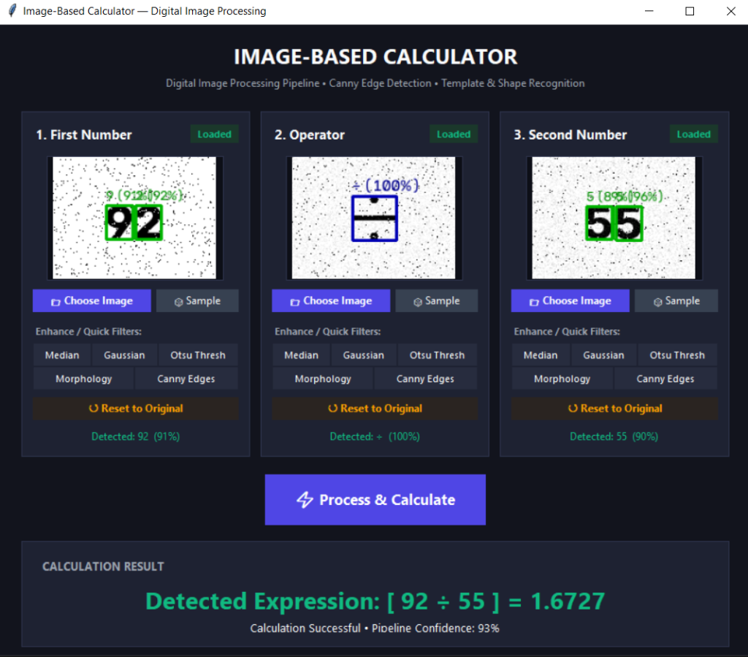
(Original -> Gray -> Denoised -> Threshold -> Morph -> Canny)
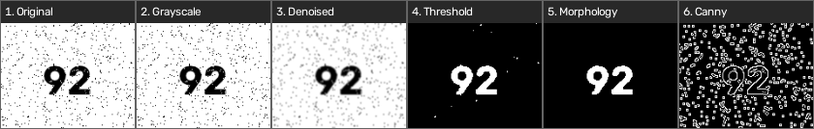
(Original -> Gray -> Denoised -> Threshold -> Morph -> Canny)
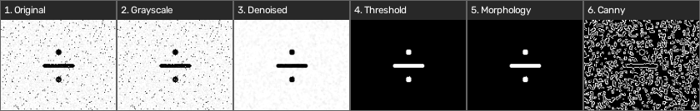
(Original -> Gray -> Denoised -> Threshold -> Morph -> Canny)
